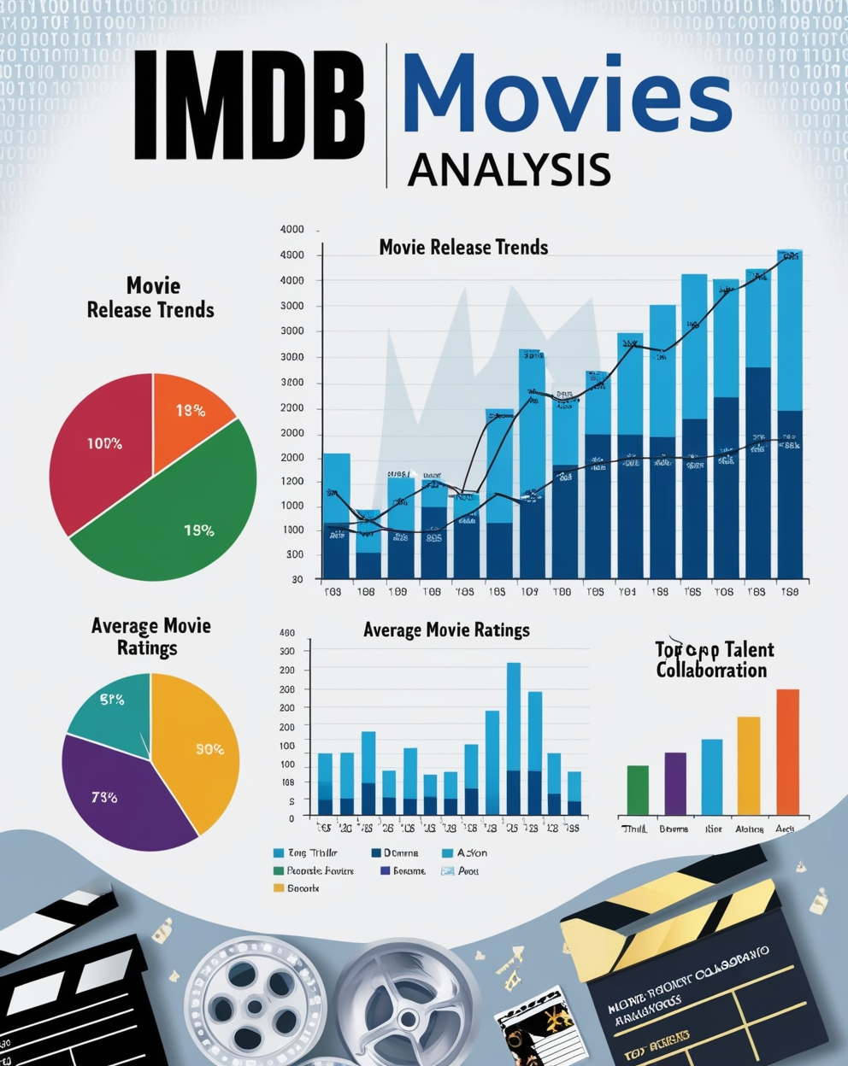

**Conclusion of the IMDb Movies Analysis Project**

**1. Genre Popularity and Production Trends:**

* The analysis of genre popularity revealed that Thriller, Drama, and Action are among the most produced and popular genres. These genres not only have a large number of films but also attract significant audience attention.
* The Thriller genre, in particular, stood out with a high ranking in terms of the number of movies produced, indicating its consistent demand. Bolly Movies should leverage this insight to continue producing content in these genres to cater to both existing and emerging audience preferences.

**2. Ratings and Quality of Content:**

* The ratings analysis underscored the importance of producing high-quality films that resonate with audiences. Movies that achieve higher ratings tend to perform better both critically and commercially.
* Focusing on the production of films with strong narratives, excellent direction, and standout performances can lead to higher average ratings. Bolly Movies should aim to consistently produce content that meets or exceeds audience expectations to maintain and enhance their reputation in the market.

**3. Star Power and Talent Collaboration:**

* The crew analysis highlighted the impact of collaborating with top-tier directors and actors. Directors and actors who consistently deliver high-rated films contribute significantly to the success of movies.
* Bolly Movies should continue to engage with leading directors and actors, especially those identified as top performers in their respective genres, to maximize the chances of producing successful films.

**4. Global Market Expansion:**

* With Bolly Movies venturing into the global market, the analysis of multilingual movies and their success rates is particularly relevant. The data suggests that there is a growing market for multilingual films that can cater to diverse audiences across different regions.
* Bolly Movies should capitalize on this opportunity by producing content that appeals to international audiences, potentially increasing their market share outside India.

**5. Audience Engagement and Long-Term Success:**

* Producing movies with high rewatch value is crucial for long-term success. Movies that offer complex narratives, strong character development, and emotional depth are more likely to encourage repeat viewings, leading to sustained revenue over time.
* Bolly Movies should focus on creating content that not only entertains but also engages audiences on a deeper level, ensuring longevity in the market.

**6. Strategic Content Focus:**

* Based on the insights gathered from the analysis, Bolly Movies should strategically focus on producing content in genres with proven popularity, collaborate with top industry talent, and expand their reach into global markets with multilingual productions.
* Additionally, ensuring that each production is of high quality, with the potential for high ratings and audience engagement, will be key to maintaining and enhancing Bolly Movies’ position in the competitive film industry.